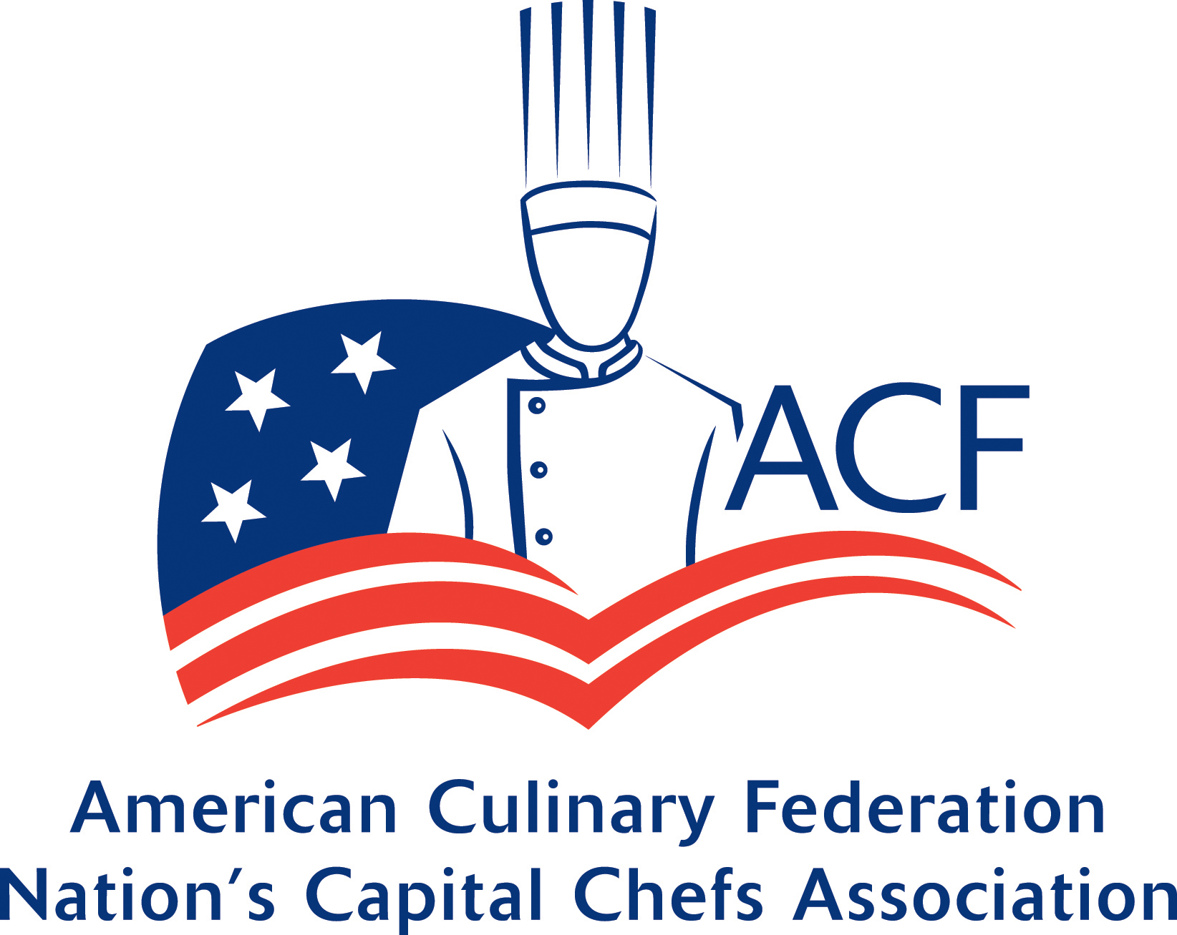
Annual Sponsorship Investment Levels: $250, $500, $1000
Sponsorship provides the Nation’s Capital Chef’s Association with the financial support to develop meaningful educational opportunities for our members and guests. Our sponsors assist in the growth of our association through support of our meetings and events, food donations and their membership. We are honored to have these sponsors as advocates for our association as well as our foodservice partners.
Sponsorships can be paid via check to: 12215 Tulip Grove Drive Bowie, MD 20715

Sponsorship Level | Gold $1000 | Silver $500 | Bronze $250
Donation receipt, tax deductable | Yes | Yes | Yes
Thank you letter and certificate | Yes | Yes | Yes
Website acknowledgment with logo and link | Top of the sponsor page | Center of the sponsor page | Bottom of the sponsor page
Logo and link on each marketing email sent out quarterly to over 800 chefs and culinarians nationwide | Yes, same as above | Yes, same as above | Yes, same as above
Marketing email sent to all members on behalf of NCCA – Sponsor to provide content | 4 per year | 2 per year | 1 per year
15 minutes to present to members about your company | Each quarter | Biannually | Once a year
Complimentary Associate membership in the ACF (a $290 value) | 1 per year | Not applicable | Not applicable
Free booth space at the NCCA Annual Vendor Fair ($50 value) | Yes | Yes | Not applicable

